# **ADLA – USQL Hand on Labs**

Create Data Lake Analytics Service

1. Sign on to the [Azure portal](https://portal.azure.com/).
2. Click **Create a resource** > **Data + Analytics** > **See All** > **Scroll Down** > **Data Lake Analytics** > **Create.**
3. Select values for the following items:
   1. **Name**: Name your Data Lake Analytics account (Only lower-case letters and numbers allowed).
   2. **Subscription**: Choose the Azure subscription used for the Analytics account.
   3. **Resource Group**. Select an existing Azure Resource Group or create a new one.
   4. **Location**. Select an Azure data center for the Data Lake Analytics account.
   5. **Data Lake Store**: Follow the instruction to create a new Data Lake Store account or select an existing one.
4. Optionally, select a pricing tier for your Data Lake Analytics account.
5. Click **Create**.

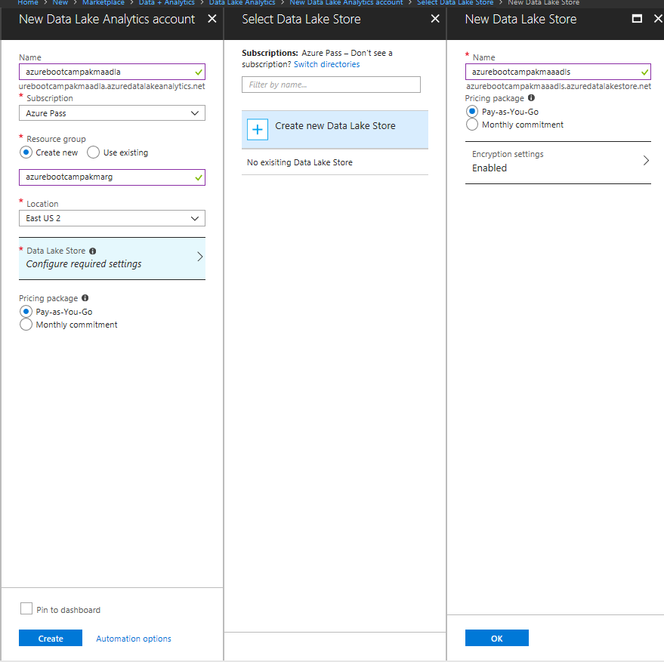

Loading Data

1. Click **All Resources** > azurebootcampakmaadls **(Name of your Azure Data Lake Store)** created during the previous step.
2. Click on Data Explorer
3. Click **New Folder** > **staging**
4. Click **OK**
5. Click **New Folder** > **reporting**
6. Click **OK**
7. Click **New Folder** > **cleansed**
8. Click **OK**
9. Open **Folder “staging”**
10. Click **New Folder** > **drivetime**
11. Click **OK**
12. Click **New Folder** > **stores**
13. Click **OK**
14. Open **Folder staging > drivetime**
15. Click **Upload > Browse Files > Select drivetime files > Add selected files**
16. There should be **30 files in staging/drivetime folder**
17. Open **Folder staging > stores**
18. Click **Upload > Browse Files > Select store file > Add selected files**
19. There should be **1 file in staging/stores folder**